**Project Form**

Some fields are added on the project form, and these are created with the BOC.

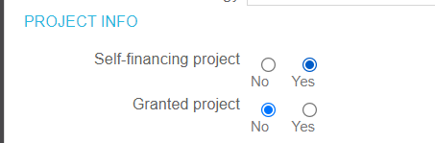

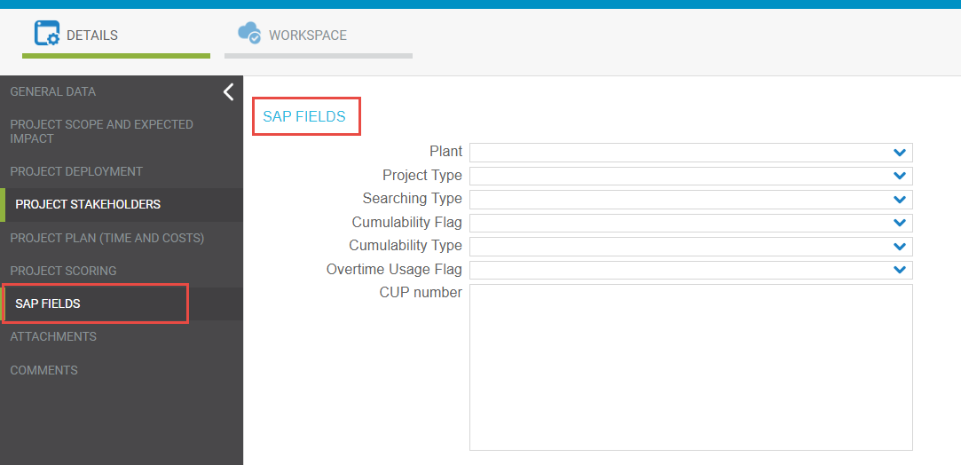

The data from these fields along with other project data is sent back to Fincantieri with the help of Stored procedure, which actually calls on the API. The SP is set into the Job “SendDataToSAP”.

SendProjectDataToSAPAPI



There is also a possibility of updating the project form data, received from the SAP via SOAP services.

Job: UpdateFormsFromSAP

Stored Procedure: UpdateProjectFormSAP

**Deliverable Form**

Some fields were added on the deliverable form.

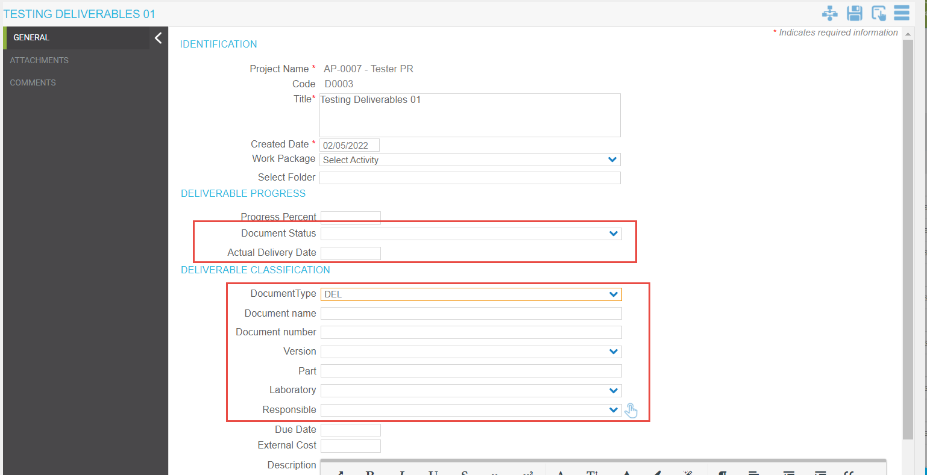

The data from these fields along with other details is sent back to Fincantieri with the help of Stored procedure, which actually calls on the API. The SP is set into the Job “SendDataToSAP”.

Stored Procedure: SendDeliverableDataToSAPAPI

There is also a possibility of updating the deliverable form data, received from the SAP via SOAP services.

Job: UpdateFormsFromSAP

Stored Procedure: UpdateDeliverableFormSAP

We also have a job that manages the deliverable.

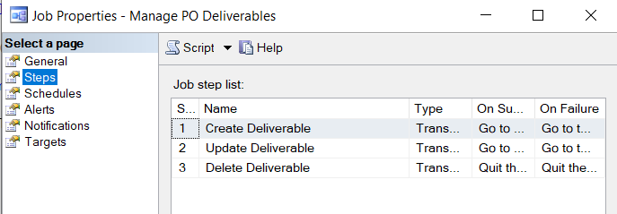

Create SP: CREATE_DELIVERABLE_OBJECT

Update SP: UpdateDeliverableFormSAP

Delete SP: DEL_PO_DELIVERABLE